

FIT5057 Project Management

Assignment Two – Team Assignment

Tempest

September 2024

Student ID: 27030768

Full Name: Adrian Leong Tat Wei

Team number: S03

Applied class: Saturday 11 am

# 

# 

# Contents

**FIT5057 Assignment 2 Writing Guide and template 1**

**Contents 2**

**DELIVERABLE 1: Project Integration Management 3**

Task 1 Project Charter 3

**DELIVERABLE 2: Project Scope Management 5**

Task 2.1 Requirements Traceability Matrix (RTM) 5

Task 2.2 Project Scope Statement 7

**DELIVERABLE 3: Project Work Breakdown Structure (WBS) and Schedule 8**

Task 3.1 Work Breakdown Structure (WBS) 9

Task 3.2 Team collaboration and Short reflection 10

Task 3.3 Gantt Chart 11

Task 3.4 In-class demonstration of Gantt Chart and team Reflection 12

**DELIVERABLE 4: Project Cost Management 12**

Task 4.1 Cost Model - one page 12

Task 4.2 Cost Baseline 13

Task 4.3 Assumptions 13

**DELIVERABLE 5: Project Risk Management 0**

Task 5.1 Risk Register 0

Task 5.2 Probability & Impact Rationale 0

Task 5.3 The Matrix & Analysis 0

**DELIVERABLE 6: Project Quality Management 1**

Task 6.1 Quality Standards/Requirements 1

Task 6.2 Metrics and Measurement 1

**DELIVERABLE 7: Project Stakeholder and Communication Management 0**

Task 7.1 Building Your Stakeholder Register 0

Task 7.2 Engagement Strategy 0

**References 0**

**GENERATIVE AI - Acknowledgement of use 0**

# 1: Project Integration Management

**Project Title**: Tempest

**Project Start Date:** 1/1/25 **Projected Finish Date:** 18/11/25

**Budget Information:**

**$1.125M**

**Project Manager:** Adrian Leong Tat Wei

Phone: +601154028630

e-mail: adrian@projectconsultants.com

**Project Objectives:**

Create a novel and engaging 3rd person fantasy action arena game, being the first of its genre and drawing a large and loyal player base to spread NexaForge as agame developer of choice.

**Main Project Success Criteria:**

To break 1 million monthly active users and a 1:10 daily active user:monthly active user ratio by the end of the 3 year time frame.

**Project development approach:**

Waterfall/Predictive

**Roles and Responsibilities**

| **Role in the project** | **Name** | **Position in the organisation/contract** | **Contact Information** |
| --- | --- | --- | --- |
| Program Director | John Kennedy | Program Director | john@projectconsultant.com |
| Project Manager | Adrian Leong | Project Manager | adrian@projectconsultants.com |
| Technical Lead | Charles Anderson | Lead Engineer | charles@projectconsultants.com |
| Platform Engineer | Elizabeth Edwin | Platform Engineer | elizabeth@projectconsultants.com |
| Developer | Chad Miller | Senior Developer | chad@projectconsultants.com |
| Developer | Mary Brown | Senior Developer | mary@projectconsultants.com |
| Developer | Bob Smith | Developer | bob@projectconsultants.com |
| Developer | Sarah Wilson | Developer | sarah@projectconsultants.com |
| Developer | Robert Williams | Developer | robert@projectconsultants.com |
| Developer | Jennifer Davis | Developer | jennifer@projectconsultants.com |
| Test Analyst | Alice Johnson | Senior Test Analyst | alice@projectconsultants.com |
| Test Analyst | Michael Jones | Senior Test Analyst | michael@projectconsultants.com |

**Sign-off:** John, Adrian, Charles, Elizabeth, Chad, Mary, Bob, Sarah, Robert, Jennifer, Alice, Michael

# 2: Project Scope Management

## 2.1 Requirements Traceability Matrix (RTM)

| **REQUIREMENTS TRACEABILITY MATRIX** | | | | | |
| --- | --- | --- | --- | --- | --- |
| **Project Name:** | Tempest | | | | |
| **Project Manager Name:** | Adrian Leong Tat Wei | | | | |
| **Project Description:** | Create a novel and engaging 3rd person fantasy action arena game. | | | | |
| ***ID*** | ***Requirements (Functional or Non-Functional)*** | ***Assumption(s) and/or Customer Need(s)*** | ***Category*** | ***Source*** | **Status** |
| R01 | Character skills function correctly | The game must be bug-free | Functional | Project Manager | Not Started |
| R02 | Character movement and movement skills interact properly with terrain and other skills | The game must be bug free | Functional | Project Manager | Not Started |
| R03 | At least 10 distinct playable characters | Players will enjoy having more characters to choose from | Quality | Business Objective: Engaging games | Not Started |
| R04 | Game runs on mid-tier computers and internet connectivity | Not all players will have good computers | Performance | Project Manager | Not Started |
| R05 | Game is not easily hacked/difficult to cheat in | Some players will try to cheat, ruining the experience for others | Service | Project Manager | Not Started |
| R06 | Matchmaking makes balanced matches without too long a queue time | Everyone deserves a fair match regardless of skill level | Quality | Project Manager | Not Started |
| R07 | No game-crashing bugs or game-breaking exploits | The game must be bug free | Functional | Project Manager | Not Started |
| R08 | Gameplay is visually and audibly satisfying | Good graphics and audio enhance the gaming experience | Performance | Project Manager | Not Started |
| R09 | The game has a tutorial system that allows players to easily pick up the game | Players need to know how to play the game before they can enjoy it | Training | Project Manager | Not Started |
| R10 | Gameplay should feel fluid and smooth | Fluid and smooth gameplay is most enjoyable | Performance | Business Objective: Engaging games | Not Started |
| R11 | Gameplay should facilitate player teamwork | Teamwork encourages socialising and thus improves player retention and player attraction | Quality | Business Objective: Engaging games, player retention | Not Started |
| R12 | Game should have visually pleasing superior cosmetics to sell | Better cosmetics to sell directly correlates with more sales | Performance | Business Objective: Sales | Not Started |
| R13 | In-game power-ups/items that players can buy throughout a match with in-game currency | Variance between matches is desirable for a multiplayer replayable PvP game | Functional | Business Objective: Engaging games | Not Started |
| R14 | Diverse array of status ailments and enhancements for players to use with character skills/items | Different players will appreciate there being multiple ways to play the game | Quality | Business Objective: Engaging games | Not Started |
| R15 | User interface and controls should be intuitive and easy to learn | Ease of learning the game means less barrier to enjoying the game | Quality | Project Manager | Not Started |
| R16 | Game servers can handle the playerbase | Playerbase might be large | Service | Project Manager | Not Started |
| R17 | Game characters are balanced in performance for all characters to be competitively viable | Different people enjoy different characters | Quality | Business Objective: Engaging games | Not Started |

## 2.2 Project Scope Statement

| **PROJECT** | **DATE** |
| --- | --- |
| Tempest | 30/9/2024 |
| **PROJECT BACKGROUND, OBJECTIVES and OUTCOMES** | |
| Background: At NexaForge, we seek to provide engaging experiences beyond AAA titles to a broad audience, balancing innovation and accessibility. To increase player retention, we propose project Tempest. Tempest is a 3rd person fantasy action-arena where players team up to battle against another team of players in quick rounds. Be it a warrior, a sorcerer, a cleric, an assassin, players can be the vanguard, control the battlefield, support their allies or disrupt the enemy backlines.  Our project aims to improve player retention rates, increase player play frequency and most of all, increase player engagement.  Objectives:  Exploit a first mover’s advantage to be the first PvP non-shooter fantasy action game.  Deliver a novel, immersive and engaging gaming experience  Build a loyal playerbase who will continue playing games from NexaForge  Advertise NexaForge as a good game developer  Outcomes:  Increased playerbase in size and retention rates  A stronger reputation for NexaForge as a game developer  Cosmetic sales from the game | |

| **HIGH-LEVEL PROJECT REQUIREMENTS, FUNCTIONAL & NON-FUNCTIONAL** |
| --- |
| The game is to be a multiplayer fantasy action-arena.  The game is fun, engaging and has depth.  The game visuals and audio design immerses players in the game and inspires feelings of grandeur.  Combat looks and feels fluid and smooth.  Player teamwork to bolster each other's strengths and/or cover weaknesses is emphasised.  Players feel they have a wide array of ways to handle their opponents.  The game logistics allow for a smooth gaming experience for all players.  Players are matched against others with balanced skill levels and without too long a queue time.  **Out-of-Scope:**  Due to budget and time constraints, the post-launch maintenance, updates and bug fixes will not be considered as part of the project scope, and rather be considered as maintenance of a completed project.  Multiple game modes, including a single player campaign, will also be considered out of project scope and be considered a continuation of a completed project.  Translating the game to multiple languages will be out of project scope.  Porting the game from PC to cross-platform, will be considered out of the project scope. |

| **DELIVERABLES** |
| --- |
| The game itself: Tempest, a 3rd person fantasy action arena where players team up to battle against another team of players with various characters of diverse playstyles and archetypes to choose from.  Visual assets: The art and character models created for use in the game    Audio assets: The music and sound effects created for use in the game.  Anti-cheat engine: The anti-cheat technology developed for the game.  Matchmaking system: The matchmaking system used to match a team of varying skill levels with another, ensuring fair and balanced matches without too long a queue time. |

| **ASSUMPTIONS** |
| --- |
| Server infrastructure and integration is done by NexaForge’s in-house team of experts.  The hardware and software (e.g. the computers and the game engine) for developing the games are already owned by NexaForge and do not incur any cost to use.  The game engine owned by NexaForge as mentioned above has built-in reusable functionality for basic core features of game development e.g. for collision detection with terrain (Björklund, 2019).  Developers may ask seniors/lead engineers for quick help on their work, as this is a small portion that is not counted towards the working hours of the seniors/lead engineers.  Some unpaid interns may be hired to help with smaller and easier tasks.  The post-launch projects of the mentioned out-of-scope projects are highly recommended to be undertaken after the completion of this project. |

# 

# 3: Project Work Breakdown Structure (WBS) and Schedule

## 3.1 Work Breakdown Structure (WBS)

| **Task Name** | **Duration (weeks)** |
| --- | --- |
| 1. Pre-Production |  |
| 1.1 Game concept and design document |  |
| 1.1.1 Game format | 1 |
| 1.1.2 Character concept designs | 2 |
| 1.1.3 Game thematic ambience | 1 |
| 1.2 Graphics and art styles |  |
| 1.2.1 Art style design | 2 |
| 1.2.2 Character and skill visual design | 2 |
| 1.2.3 Terrain landscape design | 1 |
| 1.2.4 UI design | 1 |
| 1.3 Gameplay/combat system design |  |
| 1.3.1 Combo/stagger mechanics | 2 |
| 1.3.2 Status ailment/enhancement mechanics | 1 |
| 1.3.3 Item/power-up design | 1 |
| 1.3.4 Character movement design | 2 |
| 1.4 Logistics and operations |  |
| 1.4.1 Performance optimization design | 4 |
| 1.4.2 Anti-cheat design | 4 |
| 1. Production |  |
| 2.1 Map terrain development/design |  |
| 2.1.1 Visual environment | 10 |
| 2.1.2 Pathable terrain design | 10 |
| 2.2 Character model/physics |  |
| 2.2.1 3-D model of characters | 4 |
| 2.2.2 Physics of character | 4 |
| 2.2.3 Character animations | 4 |
| 2.3 Core gameplay systems development |  |
| 2.3.1 Gameplay mechanics and skills | 12 |
| 2.3.2 Playable character combat integration | 4 |
| 2.3.3 UI/UX | 2 |
| 2.3.4 Initial Game balance | 4 |
| 2.4 Sound systems |  |
| 2.4.1 Sound effect design | 6 |
| 2.4.2 Music composing | 6 |
| 2.5 Logistics and Operations |  |
| 2.5.1 Game optimization | 4 |
| 2.5.2 Matchmaking system | 4 |
| 2.5.3 Tutorial | 3 |
| 2.5.4 Anti-cheat system | 5 |
| 3.0 Testing/bug-fixing | 8 |

## 3.2 Team collaboration and Short reflection

Having discussed the WBS with the rest of the team, the importance of the game’s logistics and operations was highlighted and added. The game needs to be free of bugs, cheats and exploits, be able to run on mid-level hardware and internet connectivity, and should also include a tutorial system to teach players how to play the game.

The WBS hierarchy was also reorganised to have more level 3 tasks under level 2 work packages, with fewer stand-alone level 2 tasks.

## 3.3 Gantt Chart

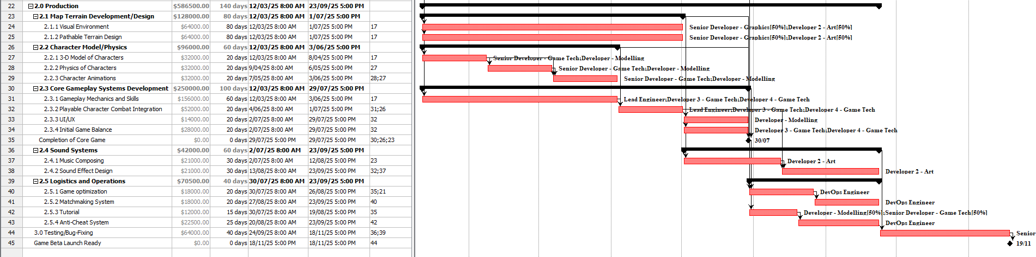

Milestones:

Completion of Game Design Concept

* Groundwork for how to create the game is completed

Completion of Pre-Production

* Groundwork for the game, including its servers and logistics are completed.

Completion of Core Game

* Barebones version of a playable game as described is completed.

Game Beta Launch Ready

* Game is completed enough for a beta launch.

Rationale:

The durations are matched to a rough estimate of how long each task would take. Harder tasks are allocated more time and more people to work on it. Predecessors are set to the minimum prerequisite level-two tasks or milestones needed, items are worked on concurrently where possible, while trying to minimise overloaded time periods.

## 

## 3.4 In-class demonstration of Gantt Chart and team Reflection

# 4: Project Cost Management

## 4.1 Cost Model

Labour cost (Shapley, n.d.):

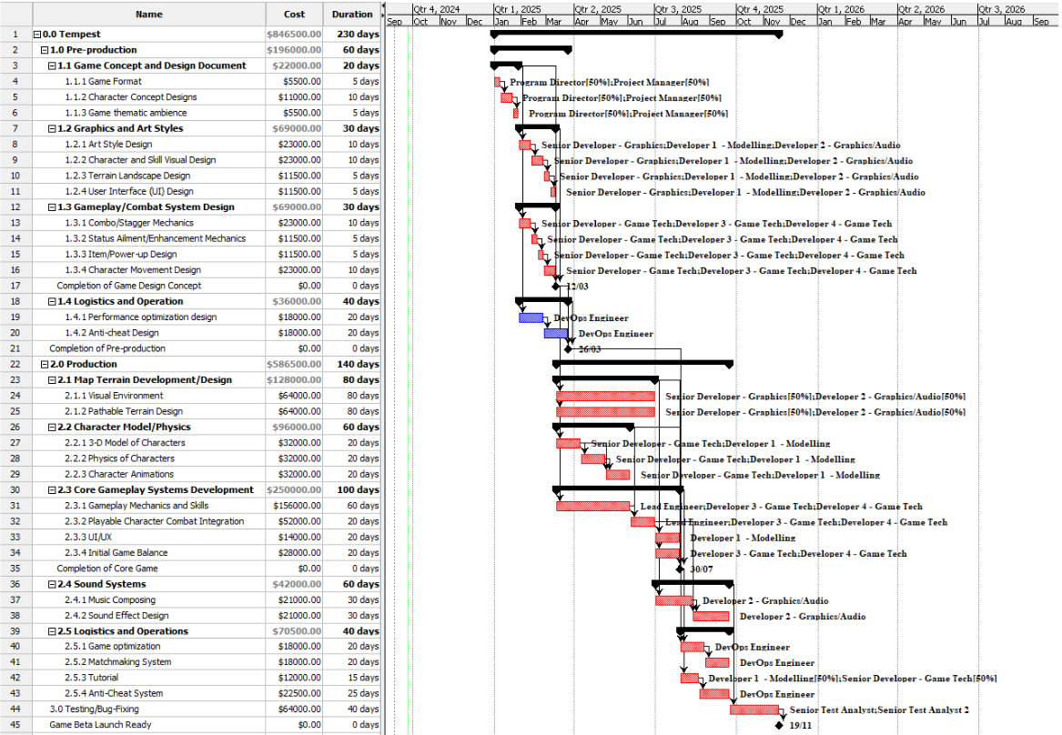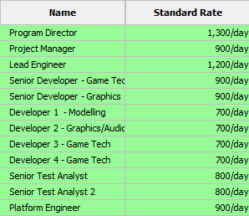

## 4.2 Cost Baseline

## 

## 4.3 Assumptions

Assumptions:

NexaForge, being an already established gaming company, already owns the hardware and software required to do this project, and thus these are excluded from the cost calculations.

Server infrastructure and integration is done by NexaForge’s in-house team of experts, and the cost of server infrastructure is also excluded from the cost calculations.

The game engine owned by NexaForge as mentioned above has built-in reusable functionality for basic core features of game development e.g. for collision detection with terrain (Björklund, 2019).

Developers may ask seniors/lead engineers for quick help on their work, as this is a small portion that is not counted towards the working hours of the seniors/lead engineers.

Some unpaid interns may be hired to help with smaller and easier tasks.

# 5: Project Risk Management

## 5.1 Risk Register

| RISK ID | RANK | RISK DESCRIPTION | IMPACT DESCRIPTION | IMPACT  LEVEL | PROBABILITY LEVEL | PRIORITY LEVEL | RISK RESPONSE | RISK OWNER |
| --- | --- | --- | --- | --- | --- | --- | --- | --- |
| 1 | 1 | First mover’s advantage | Monopoly on game genre market share | *5* | *3* | 1 | Exploit | NexaForge |
| 2 | 2 | Shifting market trends | Lack of player interest | 4 | 3 | 2 | Mitigate | NexaForge |
| 3 | 3 | Government regulations | Possible ban on game until changes are made | 5 | 2 | 3 | Mitigate | NexaForge |

## 

## 5.2 Probability & Impact Rationale

1. Shifting market trends – the video game industry has been changing extremely rapidly. And it’s not just due to technology advancements, or indie games would never have been able to rise to compete with AAA games. (Goh et al., 2023)  
  
 Likelihood: Moderate  
 Impact: Moderately High  
  
 Potential response: Mitigate – we can mitigate this risk by analysing market trends, and adapting our game to match market trends. Straying too far from our original audience will end up alienating our player-base, but a small and gradual amount of adaptation is generally safe enough.

2. Government regulations – Governments regulate gaming, and some countries do this a lot more than others. Some recent examples would be China restricting gaming time for minors, and Europe cracking down on gambling. These represent a risk in blocking our access to said countries.  
  
 Likelihood: Low  
 Impact: High  
  
 Potential response: Mitigate – by designing our games ethically, we can be generally safe from changing regulations. Failing which, we can redesign our game and/or monetization strategies.

3. First mover’s advantage – As the first game in the genre, this represents “an opportunity to growth that is both quick and profitable” (Härmä & LeGrand, 2013, p22). If exploited well, we could monopolise a large audience with relative ease, as we have no competitors yet.   
 Likelihood: Moderately High  
 Impact: High  
  
 Potential response: Exploit – as we do not have competitors yet, we can secure a large audience simply by making the best game we can and advertising it.

## 5.3 The Matrix & Analysis

| **P R O B A B I L I T Y** | 5 |  |  |  |  |  |
| --- | --- | --- | --- | --- | --- | --- |
| 4 |  |  |  |  |  |
| 3 |  |  |  | R2 | R1 |
| 2 |  |  |  |  | R3 |
| 1 |  |  |  |  |  |
|  |  | 1 | 2 | 3 | 4 | 5 |
|  |  | **I M P A C T** | | | | |

From the matrix above, it is evident that the first risk, first mover’s advantage, represents the greatest risk of a first mover’s advantage to be exploited. However, the second and third risks, shifting market trends and government regulations, are not too far behind, and thus should be treated with caution to mitigate it.

# 6: Project Quality Management

## 6.1 Quality Standards/Requirements

To meet the portfolio requirements of player retention and sales, balancing difficulty levels, in this case via skill-based matchmaking, and keeping players engaged, is crucial. Sarkar et al. (2017) highlights the importance of balancing difficulty to maintain player interest, and as Hamari (2015) noted, players who are invested in the game are more likely to spend. Kang et al. (2024) further emphasises the importance of good matchmaking, as excessive win streaks leads to demotivation, while by definition also leading to more losses for the rest of the playerbase, further reducing other players’ engagement.

## 6.2 Metrics and Measurement

To measure our progress in balancing difficulty levels for players, and keeping players engaged, we propose the following measurable metrics in addition to the decided D1 retention, D7 retention and M3 retention:

Player Engagement:

Following industry standards (Fields, 2013), we will measure monthly and daily active users. A higher daily active users per monthly users indicate more players are eager to keep playing regularly, and following the statistics of Valorant, Overwatch and CS:GO, 3 very popular FPS games, a ratio of 1 daily active player : 10 monthly active players is a gold standard to aim to achieve. Valorant, the most recent one, was able to pull 18 million monthly active players within the first 3 months of launch (Valorant Live Player Count & Statistics, 2024), another gold standard to reach for, albeit realistically impossible given how large a player base Riot Games already had.

Balancing Difficulty Levels For Players:

To measure how difficult matches players are facing, we will measure their win-rates and streaks. The 5th-95th percentile of players should have win-rates between 40% and 60% for the last 50 matches, and be on a win or lose streak of no longer than 10. These numbers are chosen as players having a win-rate below 40%, above 60% or on a win or lose streak of more than 10 are cases where our game has failed to give them a good gaming experience, and thus we have failed these players. Delivering a good gaming experience to less than 90% of our player base is our failure.

# 7: Project Stakeholder and Communication Management

## 7.1 Building Your Stakeholder Register

| **TITLE** | **ROLE IN PROJECT** | **CATEGORY** | **POWER LEVEL** | **INTEREST LEVEL** | **COMMS REQUIREMENTS** | **COMMS FREQUENCY** | **CONTACT** |
| --- | --- | --- | --- | --- | --- | --- | --- |
| NexaForge CEO | Project Sponsor | External | High | High | Meetings, presentations, email | Often | bob@nexaforge.com |
| Government Regulators | Project Regulator | External | High | Low | Email | Rarely | vgccc.vic@gov.au |
| Project Manager | NexaForge infrastructure /integration team | External | Medium | High | Meetings, direct messages, email | Often | alex@nexaforge.com |
| Players | Customer | External | Low | High | Blog post/website update | Rarely | N/A |
| Streamers | Advertiser/Play Tester/Game Feedback | External | High | High | Interviews, meetings, direct messages, email | Often | winterstarcraft@gmail.com |
| Project Manager | Project Manager | Internal | High | High | Meetings, direct messages, email | Weekly updates | adrian@projectconsultants.com |
| Developer Team | Developers | Internal | High | High | Meetings, direct messages, email | Weekly updates | chad@projectconsultants.com |
| Test Analyst Team | Test Analysts | Internal | Medium | High | Presentations, meetings, email | Weekly updates | alice@projectconsultants.com |

## 

## 

## 7.2 Engagement Strategy

Stakeholder 1: Client (NexaForge CEO)

Clients like NexaForge’s CEO, being high-power stakeholders, can significantly influence project outcomes, sometimes unintentionally hindering their potential (Nikolova & Devinney, 2009). According to 'Application of Game Theory Methods to Optimize the Stakeholder Management Process' (2024), open communication about any problematic hurdles arising is essential for maintaining a mutually beneficial relationship. However, as Nikolova & Devinney also note, their ultimate decision-making authority necessitates careful persuasion to guide project choices toward shared objectives and prevent poorly-informed decisions.

Stakeholder 2: Streamers

Streamers, people who play and discuss games and showcase them to their audiences, have a high interest in the game and varying amounts of power. They advertise the games they play, are generally very knowledgeable of games and how they can be better (Parker & Perks, 2021), and can arguably make or break a game’s success (Johnson & Woodcock, 2018). As such, we should engage directly with streamers, offering them incentives to showcase our game and interview them for feedback and ways to improve our game,

# 

# References

Björklund, R. (2019). *Software Reuse in Game Development: Creating Building Blocks for Prototyping* (By KTH ROYAL INSTITUTE OF TECHNOLOGY & EA DICE AB) [Thesis]. <https://www.diva-portal.org/smash/get/diva2:1351217/FULLTEXT01.pdf>

Härmä, A., & LeGrand, N. (2013, May 31). *THE SUCCESS FACTORS OF THE FINNISH MOBILE GAME INDUSTRY: A STRATEGIC OVERVIEW - Cases Rovio & Supercell*. International Business Degree Programme.<https://www.theseus.fi/bitstream/handle/10024/62924/Harma_Aleksanteri.pdf>

Goh, E., Al-Tabbaa, O., & Khan, Z. (2023). Unravelling the complexity of the Video Game Industry: An integrative framework and future research directions. *Telematics and Informatics Reports*, *12*, 100100. <https://doi.org/10.1016/j.teler.2023.100100>

Sarkar, A., Williams, M., Deterding, S., & Cooper, S. (2017). Engagement effects of player rating system-based matchmaking for level ordering in human computation games. *ACM*. <https://doi.org/10.1145/3102071.3102093>

Hamari, J. (2015). Why do people buy virtual goods? Attitude toward virtual good purchases versus game enjoyment. *International Journal of Information Management*, *35*(3), 299–308. <https://doi.org/10.1016/j.ijinfomgt.2015.01.007>

Kang, H., Suh, C., & Kim, H. K. (2024). Match experiences affect interest: Impacts of matchmaking and performance on churn in a competitive game. *Heliyon*, *10*(3), e24891. <https://doi.org/10.1016/j.heliyon.2024.e24891>

Fields, T. V. (2013). Game Industry Metrics Terminology and Analytics Case Study. In *Springer eBooks* (pp. 53–71). <https://doi.org/10.1007/978-1-4471-4769-5_4>

*Valorant Live Player Count & Statistics*. (2024, September). Valorant Live Player Count & Statistics. Retrieved September 27, 2024, from <https://activeplayer.io/valorant/>

Nikolova, N., & Devinney, T. M. (2009). Influence and power dynamics in client‐consultant teams. *Journal of Strategy and Management*, *2*(1), 31–55. <https://doi.org/10.1108/17554250910948695>

*Application of Game Theory Methods to Optimize the Stakeholder Management Process*. (2024, May 15). IEEE Conference Publication | IEEE Xplore. <https://ieeexplore.ieee.org/abstract/document/10629255>

Parker, F., & Perks, M. E. (2021). Streaming ambivalence: Livestreaming and indie game development. *Convergence the International Journal of Research Into New Media Technologies*, *27*(6), 1735–1752. <https://doi.org/10.1177/13548565211027809>

Johnson, M. R., & Woodcock, J. (2018). The impacts of live streaming and Twitch.tv on the video game industry. *Media Culture & Society*, *41*(5), 670–688. <https://doi.org/10.1177/0163443718818363>

Shapley, A. (n.d.). *IT CONTRACTOR RATES GUIDE*. <https://www.hays.com.au/documents/276732/1102429/Hays+Technology+Contractor+Rates+Guide.pdf>

# 

# GENERATIVE AI - Acknowledgement of use

I used Gemini (https://gemini.google.com) for estimating the timeline and cost, and to refine some of my sentence structure. I also used it to better understand the project requirements.

I used Quillbot (<https://quillbot.com/citation-generator/apa>) for generating the in-text citations and the reference list above.